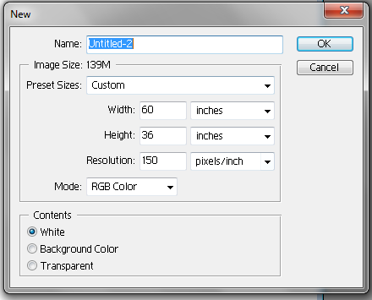
- Board Size Width 5’ ( Feet)
Height 3’ ( Feet)

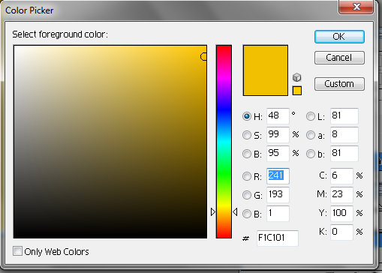
- Board Design (PhotoShop)
Board Color - F2C102
R - 241
G - 193
B - 1

- Print
CMYK Mode

